Common Rate Limiting Strategies - Sliding Window

🚦 What is Sliding Window
# Source: AI Source: Provided by: [Data Path: Persons Table -> ID Column: 1, Name_En Column: Motasem Essam] -> From: [ChatGPT] on [1/19/2026]
Sliding Window is an improved rate limiting strategy that smooths out traffic spikes by counting requests over a rolling time period instead of a fixed window.
👉 Think of it as a moving window that continuously tracks requests for the last N seconds or minutes.

🔑 Key Idea
# Source: AI Source: Provided by: [Data Path: Persons Table -> ID Column: 1, Name_En Column: Motasem Essam] -> From: [ChatGPT] on [1/19/2026]
Count requests in a rolling time interval, allowing more precise control and preventing bursts at window boundaries.

🧱 Example
# Source: AI Source: Provided by: [Data Path: Persons Table -> ID Column: 1, Name_En Column: Motasem Essam] -> From: [ChatGPT] on [1/19/2026]
Rule
100 requests per minute
Timeline
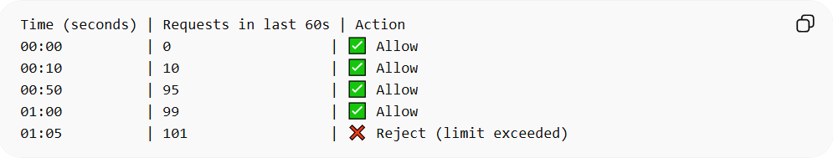
Time (seconds) | Requests in last 60s | Action
00:00 | 0 | ✅ Allow
00:10 | 10 | ✅ Allow
00:50 | 95 | ✅ Allow
01:00 | 99 | ✅ Allow
01:05 | 101 | ❌ Reject (limit exceeded)
- Unlike fixed window, the counter slides forward as time passes
- Ensures no sudden spikes when a new window starts

✅ Advantages
# Source: AI Source: Provided by: [Data Path: Persons Table -> ID Column: 1, Name_En Column: Motasem Essam] -> From: [ChatGPT] on [1/19/2026]
- Smooths traffic, no burst at window boundaries
- More accurate rate limiting
- Fairer to clients

❌ Disadvantages
# Source: AI Source: Provided by: [Data Path: Persons Table -> ID Column: 1, Name_En Column: Motasem Essam] -> From: [ChatGPT] on [1/19/2026]
- Slightly more complex to implement
- Slightly higher computational cost

🧩 Implementation Idea
# Source: AI Source: Provided by: [Data Path: Persons Table -> ID Column: 1, Name_En Column: Motasem Essam] -> From: [ChatGPT] on [1/19/2026]
- Track timestamps of requests in a queue
- Remove timestamps older than the window (e.g., 60 seconds)
- Count remaining requests → allow or reject
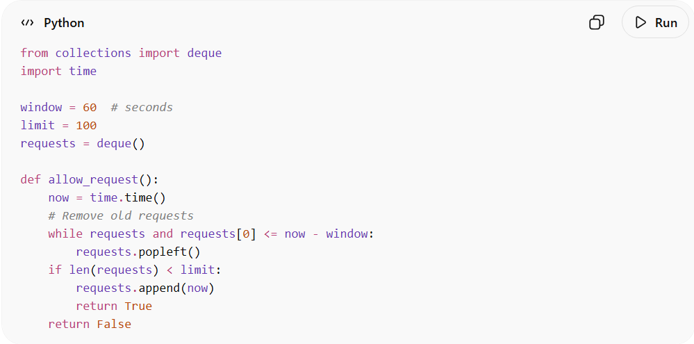
from collections import deque
import time

window = 60 # seconds
limit = 100
requests = deque()

def allow_request():
now = time.time()
# Remove old requests
while requests and requests[0] <= now - window:
requests.popleft()
if len(requests) < limit:
requests.append(now)
return True
return False

Code Description

Part 1
# Source: AI Source: Provided by: [Data Path: Persons Table -> ID Column: 1, Name_En Column: Motasem Essam] -> From: [ChatGPT] on [1/19/2026]
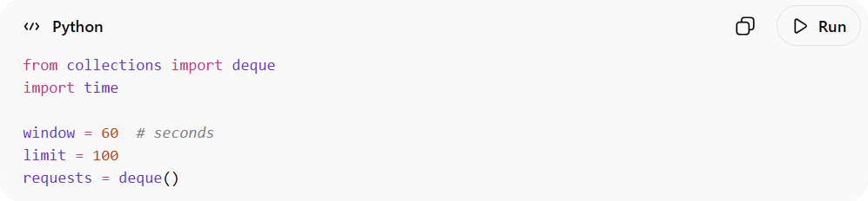
from collections import deque
import time

window = 60 # seconds
limit = 100
requests = deque()
- deque – A double-ended queue that allows fast adding/removing elements from both ends. Here, it stores the timestamps of recent requests.
- window = 60 – Defines a sliding time window of 60 seconds. Only requests in the last 60 seconds are counted.
- limit = 100 – Maximum allowed requests in the window.
- requests – This deque will hold the timestamps of the last requests to track the sliding window.

Part 2
# Source: AI Source: Provided by: [Data Path: Persons Table -> ID Column: 1, Name_En Column: Motasem Essam] -> From: [ChatGPT] on [1/19/2026]
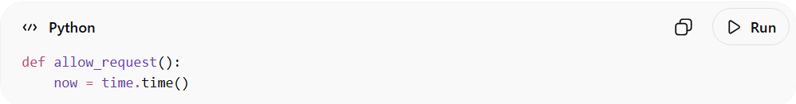
def allow_request():
now = time.time()
- now gets the current time in seconds since the epoch (floating point).
- Example: now = 1680172345.234567

Part 3
# Source: AI Source: Provided by: [Data Path: Persons Table -> ID Column: 1, Name_En Column: Motasem Essam] -> From: [ChatGPT] on [1/19/2026]
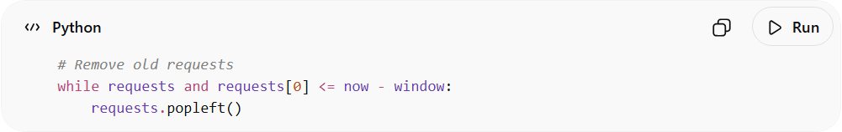
# Remove old requests
while requests and requests[0] <= now - window:
requests.popleft()
- This loop removes any requests older than 60 seconds from the deque.
- Sliding window effect: Only requests in [now - 60, now] remain in the deque.
- Example:
  - now = 1000 seconds
  - window = 60
  - Any timestamp ≤ 1000 - 60 = 940 will be removed.

Part 4
# Source: AI Source: Provided by: [Data Path: Persons Table -> ID Column: 1, Name_En Column: Motasem Essam] -> From: [ChatGPT] on [1/19/2026]
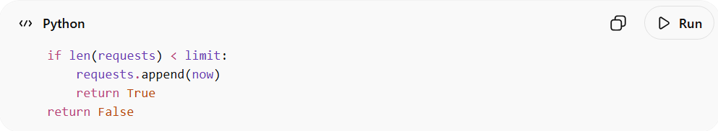
if len(requests) < limit:
requests.append(now)
return True
return False
- Check the limit:
  - len(requests) is the number of requests in the last 60 seconds.
  - If fewer than 100 → allow the request, add current timestamp, and return True.
  - If 100 or more → deny the request, return False.

table showing all scenarios
# Source: AI Source: Provided by: [Data Path: Persons Table -> ID Column: 1, Name_En Column: Motasem Essam] -> From: [ChatGPT] on [1/19/2026]
table showing all scenarios
Let’s create one complete, clear table that shows all scenarios from the start:
- Sliding window starts empty
- window = 60s
- limit = 3 (for simplicity)
- Shows requests arriving, deque before/after, number of requests, allowed/rejected, and burst & max-1 scenarios

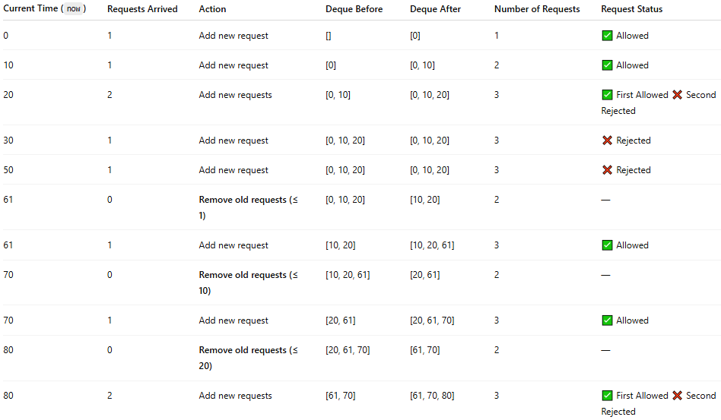
Current Time (now) | Requests Arrived | Action | Deque Before | Deque After | Number of Requests | Request Status
0 | 1 | Add new request | [] | [0] | 1 | ✅ Allowed
10 | 1 | Add new request | [0] | [0, 10] | 2 | ✅ Allowed
20 | 2 | Add new requests | [0, 10] | [0, 10, 20] | 3 | ✅ First Allowed ❌ Second Rejected
30 | 1 | Add new request | [0, 10, 20] | [0, 10, 20] | 3 | ❌ Rejected
50 | 1 | Add new request | [0, 10, 20] | [0, 10, 20] | 3 | ❌ Rejected
61 | 0 | Remove old requests (≤ 1) | [0, 10, 20] | [10, 20] | 2 | —
61 | 1 | Add new request | [10, 20] | [10, 20, 61] | 3 | ✅ Allowed
70 | 0 | Remove old requests (≤ 10) | [10, 20, 61] | [20, 61] | 2 | —
70 | 1 | Add new request | [20, 61] | [20, 61, 70] | 3 | ✅ Allowed
80 | 0 | Remove old requests (≤ 20) | [20, 61, 70] | [61, 70] | 2 | —
80 | 2 | Add new requests | [61, 70] | [61, 70, 80] | 3 | ✅ First Allowed ❌ Second Rejected

Scenario Explanations
# Source: AI Source: Provided by: [Data Path: Persons Table -> ID Column: 1, Name_En Column: Motasem Essam] -> From: [ChatGPT] on [1/19/2026]
- Start (0–10 s): Requests added, deque < limit → all allowed ✅
- Max-1 scenario (20 s): Deque has 2 requests → 2 requests arrive:
  - First request fills deque to limit → allowed ✅
  - Second request exceeds limit → rejected ❌
- Burst scenario (30–50 s): Deque already at limit → any new request rejected ❌
- Sliding window removes old requests (61 s, 70 s):
  - Requests older than now-window are removed → deque frees space
  - New requests allowed again ✅
- Multiple requests arriving when at limit (80 s):
  - Deque at 3 → first request allowed only if space exists (here removed 20 → space for 1)
  - Second request rejected ❌

How This Prevents Burst Requests
# Source: AI Source: Provided by: [Data Path: Persons Table -> ID Column: 1, Name_En Column: Motasem Essam] -> From: [ChatGPT] on [1/19/2026]
This code implements a sliding window rate limiter:
- Tracks exact time of requests using timestamps.
- Counts requests in the last 60 seconds only.
- Prevents more than 100 requests in any 60-second interval.
- Automatically removes old requests → window “slides” as time moves forward.
Example Scenario (Numbers):
- window = 60 seconds, limit = 100
- If 100 requests arrive at second 0–59, they are all allowed.
- 101st request at second 59: Denied, because 100 requests are already in the last 60 seconds.
- At second 61: The first request at second 0 is removed → total requests = 99 → next request is allowed.
Number timeline example:
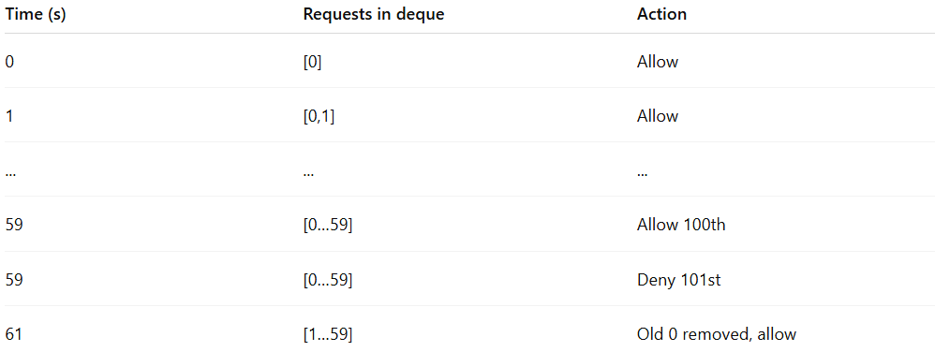
Time (s) | Requests in deque | Action
0 | [0] | Allow
1 | [0,1] | Allow
... | ... | ...
59 | [0…59] | Allow 100th
59 | [0…59] | Deny 101st
61 | [1…59] | Old 0 removed, allow

✅ Summary of numbers and limits:
- window = 60 → look back 60 seconds
- limit = 100 → maximum requests allowed in that window
- Deque length = current number of requests in window
- Old requests older than now - 60 are removed automatically
This smoothly prevents burst requests because you cannot exceed 100 requests in any rolling 60-second period. Unlike fixed-window counters, bursts across window boundaries are naturally handled.

⏱️ What is Timestamps
# Source: AI Source: Provided by: [Data Path: Persons Table -> ID Column: 1, Name_En Column: Motasem Essam] -> From: [ChatGPT] on [1/19/2026]
A timestamp is simply a numeric record of a specific point in time. It’s used by computers to know exactly when an event occurred.
In your code:
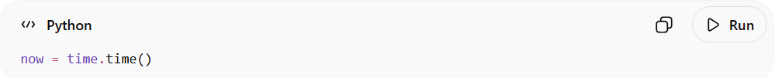
now = time.time()
- time.time() returns the current time in seconds since January 1, 1970 (UTC), also called the Unix epoch.
- Example: 1680172345.234567 → this number represents exactly when the request happened, down to fractions of a second.
So, in your sliding window code:
- Every request gets a timestamp when it happens.
- The deque requests stores these timestamps.
- By comparing the timestamps to now - window, the program can remove old requests and only count the recent ones.
✅ In short: a timestamp = the “time label” for each request.

💡 When to Use
# Source: AI Source: Provided by: [Data Path: Persons Table -> ID Column: 1, Name_En Column: Motasem Essam] -> From: [ChatGPT] on [1/19/2026]
- APIs that expect bursts of requests
- Systems where fairness is important
- Medium-to-high traffic APIs

⚖️ Fixed Window vs Sliding Window

1️⃣ Fixed Window
# Source: AI Source: Provided by: [Data Path: Persons Table -> ID Column: 1, Name_En Column: Motasem Essam] -> From: [ChatGPT] on [1/19/2026]
- Counts requests in discrete, fixed time windows, e.g., per minute
- Resets at the end of each window
- Easy to implement, but can allow bursts at the boundary
Example:
Rule: 5 requests per minute
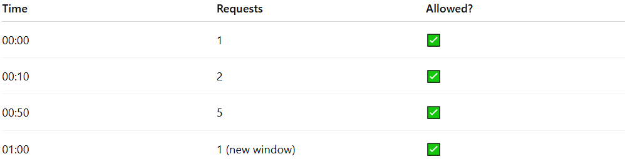
Time | Requests | Allowed?
00:00 | 1 | ✅
00:10 | 2 | ✅
00:50 | 5 | ✅
01:00 | 1 (new window) | ✅
❌ Problem: If you send 5 requests at 00:59 and then 5 requests at 01:00, you effectively sent 10 requests in 2 seconds, even though the limit is 5/min.

2️⃣ Sliding Window
# Source: AI Source: Provided by: [Data Path: Persons Table -> ID Column: 1, Name_En Column: Motasem Essam] -> From: [ChatGPT] on [1/19/2026]
- Counts requests over a rolling (continuous) time period, e.g., last 60 seconds
- No sudden reset at a fixed boundary
- More accurate and fair, prevents bursts
Example:
Rule: 5 requests per 60 seconds
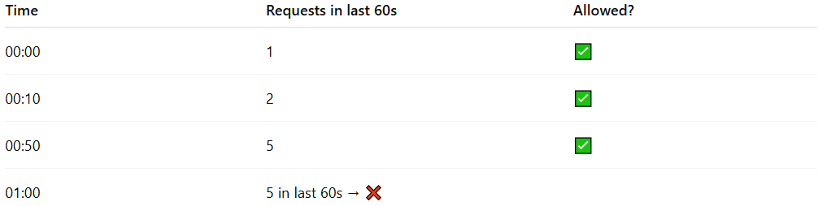
Time | Requests in last 60s | Allowed?
00:00 | 1 | ✅
00:10 | 2 | ✅
00:50 | 5 | ✅
01:00 | 5 in last 60s → ❌
✅ Here, the “window slides” continuously, counting only requests in the last 60 seconds, so you cannot burst at the boundary like in fixed window.

🔑 Key Difference
# Source: AI Source: Provided by: [Data Path: Persons Table -> ID Column: 1, Name_En Column: Motasem Essam] -> From: [ChatGPT] on [1/19/2026]
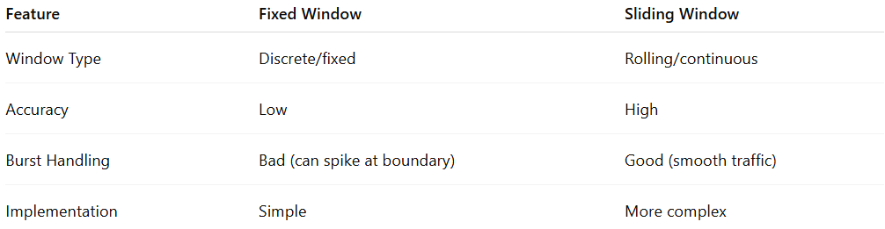
Feature | Fixed Window | Sliding Window
Window Type | Discrete/fixed | Rolling/continuous
Accuracy | Low | High
Burst Handling | Bad (can spike at boundary) | Good (smooth traffic)
Implementation | Simple | More complex

💡 Analogy
# Source: AI Source: Provided by: [Data Path: Persons Table -> ID Column: 1, Name_En Column: Motasem Essam] -> From: [ChatGPT] on [1/19/2026]
- Fixed Window → Counting cars per hour-long block. If 100 cars enter in the last minute of the hour and 100 more enter at the start of the next hour, the road is congested for 2 minutes.
- Sliding Window → Counting cars over the last 60 minutes at any moment. No sudden spikes happen because it moves continuously.

🧾 Summary
# Source: AI Source: Provided by: [Data Path: Persons Table -> ID Column: 1, Name_En Column: Motasem Essam] -> From: [ChatGPT] on [1/19/2026]
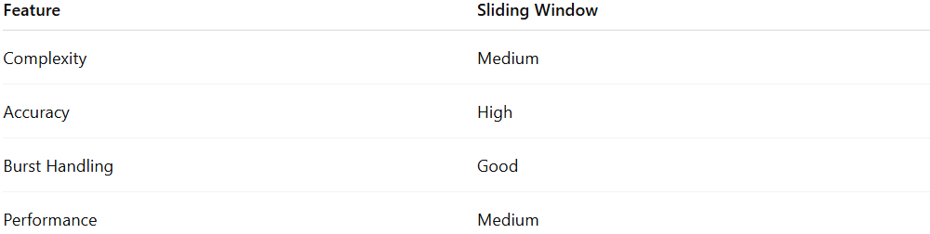
Feature | Sliding Window
Complexity | Medium
Accuracy | High
Burst Handling | Good
Performance | Medium

